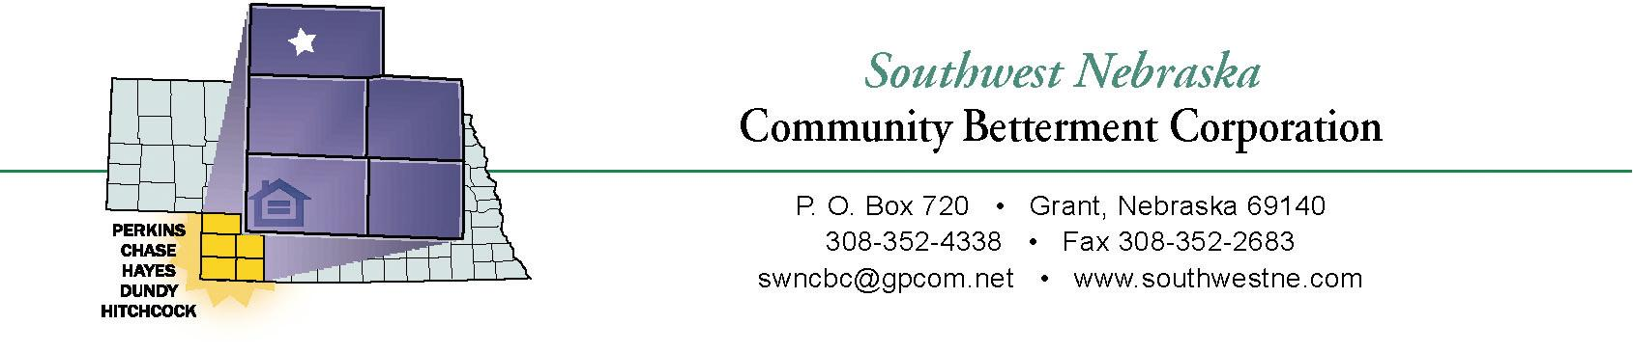

By submitting this form we/I certify that we/I have read, understand and agree to abide and to adhere to the Guidelines for the Village of Stratton Owner Occupied Rehab Program.

______________________________ _____________________
Signature Date

______________________________ _____________________
Signature Date

